**Installing Arduino IDE with Adafruit Boards**

**Important: Install Arduino 1.6.5+ from here and follow steps for SUPER easy setup:**

1. **Download Arduino IDE here:** [**https://www.arduino.cc/en/Main/Software**](https://www.arduino.cc/en/Main/Software)
2. **Follow instructions on this page to add support for Adafruit boards:** [**https://learn.adafruit.com/adafruit-arduino-ide-setup/arduino-1-dot-6-x-ide**](https://learn.adafruit.com/adafruit-arduino-ide-setup/arduino-1-dot-6-x-ide)
3. **ONLY for Windows - install drivers:**

* Download Adafruit Gemma drivers here: <http://www.adafruit.com/downloads/usbtiny_signed_8.zip>

and/or download Adafruit Flora drivers here:

<http://www.adafruit.com/downloads/Flora_win8signed.zip>

* Unzip the usbtiny_signed_8.zip file and put it into any directory.
* Plug in your Gemma into the PC via a USB port.
* Go to your device manager (Go to Start Menu -> Search for Device Manager, click on "Device Manager"), there you should see "USBtiny" or “Trinket” or “Adafruit” listed under "Other devices"
* Right click on "USBtiny"/”Trinket”/”Adafruit” and select "Update driver software"
* Click "Browse my computer for driver software"
* Browse and select the entire unzipped driver folder and click 'Next'. At this point the driver software should being installing. If it asks you, select "Always trust Adafruit"

1. **Download NeoPixel, Color Sensor and Bluefruit LE libraries and copy unzipped files to *Documents/Arduino/libraries/* directory:**

[**https://github.com/adafruit/Adafruit_NeoPixel**](https://github.com/adafruit/Adafruit_NeoPixel)

[**https://github.com/adafruit/Adafruit_TCS34725**](https://github.com/adafruit/Adafruit_TCS34725)

[**https://github.com/adafruit/Adafruit_BluefruitLE_nRF51**](https://github.com/adafruit/Adafruit_BluefruitLE_nRF51)

**Note: Use ‘git clone** [**https://github.com/adafruit/Adafruit_NeoPixel.git**](https://github.com/adafruit/Adafruit_NeoPixel.git)**’**

**‘git clone** [**https://github.com/adafruit/Adafruit_BluefruitLE_nRF51.git**](https://github.com/adafruit/Adafruit_BluefruitLE_nRF51.git)**’**

**‘git clone** [**https://github.com/adafruit/Adafruit_TCS34725.git**](https://github.com/adafruit/Adafruit_TCS34725.git)**’**

**in your *Documents/Arduino/libraries* directory if you are using a Mac**

**NeoPixels**

[**https://learn.adafruit.com/adafruit-neopixel-uberguide/overview**](https://learn.adafruit.com/adafruit-neopixel-uberguide/overview)

* Not your average LED ☺ Requires programming
* Ready-to-load code available as part of adafruit NeoPixel library

**Getting started with Flora**

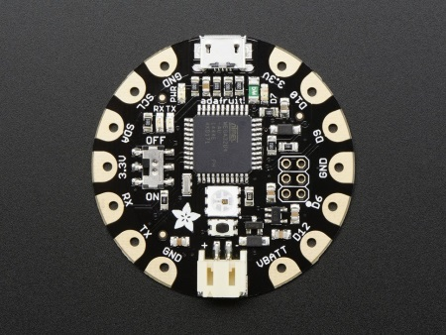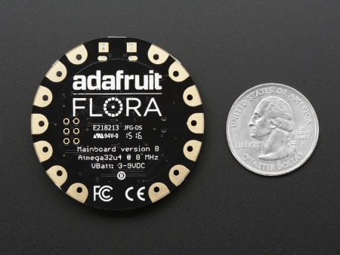

[**https://learn.adafruit.com/getting-started-with-flora**](https://learn.adafruit.com/getting-started-with-flora)

* 1.8" round x 0.3" thick
* Easy-to-sew or solder pads for embedding in your wearable project
* Based on the ATmega32u4 30K of usable flash memory

**Getting started with Gemma**

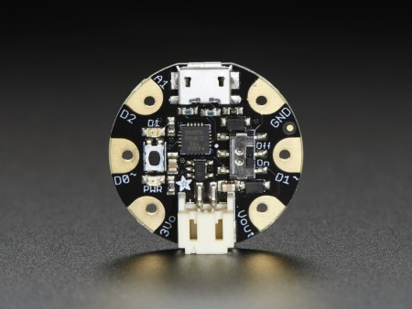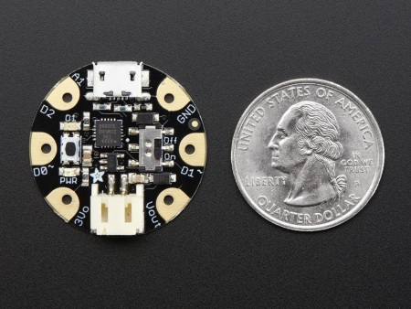

[**https://learn.adafruit.com/introducing-gemma**](https://learn.adafruit.com/introducing-gemma)

* Super small, **only 1.1" / 28mm diameter** and 0.28" / 7mm thick.
* Easy-to-sew or solder pads for embedding in your wearable project
* Low cost enough, you can use one for every weekend project
* ATtiny85 on-board, **8K of flash**, 512 byte of SRAM, 512 bytes of EEPROM

**Adafruit Color Sensor**

[**https://learn.adafruit.com/adafruit-color-sensors/overview**](https://learn.adafruit.com/adafruit-color-sensors/overview)

**Bluefruit LE**

[**https://learn.adafruit.com/adafruit-flora-bluefruit-le**](https://learn.adafruit.com/adafruit-flora-bluefruit-le)

* For use with Flora, but not Gemma due to memory constraints
* Adafruit app available for wireless control